Memory Organisation

CPU Organisation and Operation

Introduction to Assembly Programming

Dr. N. Dulay

November 2019

Preliminaries

Welcome to the Computer Systems (113) / Architecture (110) course. Over the next two terms we’ll study the basic operation and organisation of a computer. Hopefully you’ve all completed the self-study on integer representations and arithmetic. Some preliminaries first:
How to contact me
There are 2 options: (i) see me at a tutorial, (2) email me using nd@doc.ic.ac.uk
Workload
The course consists of lectures (2 per week), tutorials (1 per week), a number of pieces of assessed coursework and a lab exercise. The tutorials and lab exercise are not examined but are important as they give you an opportunity to check on your progress and to discuss problems and ideas with the tutorial helpers. The assessed coursework is marked and undertaken as homework. The lab exercise is scheduled as part of the PPT programme.
Exams
There is a single combined Christmas test that normally has 1 architecture question. The main examinations are held at the start of the summer term. Past exam papers can be accessed and viewed via the departmental homepage.
Textbooks
Unfortunately there is no single ideal introductory textbook. The following textbooks are good however:
− Structured Computer Organization (5th edition) by Andrew S. Tannenbaum, Prentice Hall
− Computer Organization and Architecture: Designing for Performance (7th Ed) by
William Stallings, Prentice-Hall.
The course also involves Intel Pentium assembly programming. For this you may wish to consider acquiring a book about Pentium programming such as:
− Guide to Assembly Language Programming in Linux by S. Dandamudi, Springer.
An excellent web resource is Wikipedia at
http://en.wikipedia.org/
Website
The course notes, tutorials, slides etc will be available via the following URL:
https://www.doc.ic.ac.uk/~nd/architecture

Note: the URL starts https, not http. You need to print your own copies.
Main Memory (RAM) Organisation

Computers employ many different types of memory (semi-conductor, magnetic disks and tapes, DVDs etc.) to hold data and programs. Each type has its own characteristics and uses. We will look at the way that Main Memory (RAM) is organised and very briefly at the characteristics of Register Memory and Disk Memory. Let’s locate these 3 types of memory in an abstract computer:

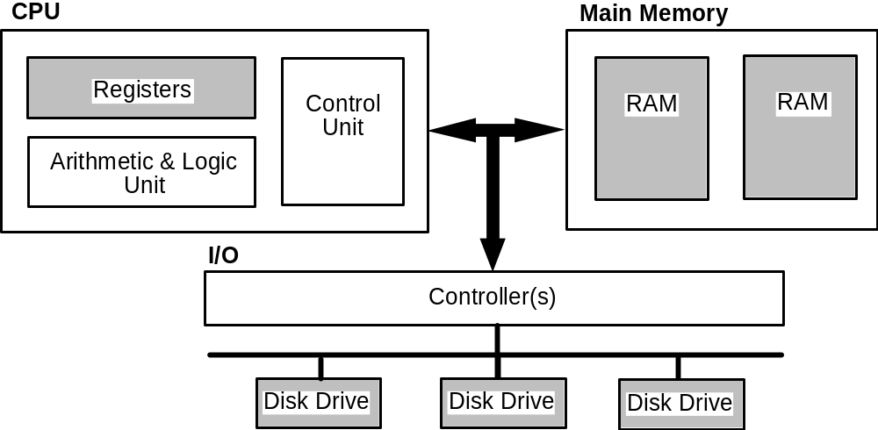

Register Memory

Registers are memories located within the Central Processing Unit (CPU). They are few in number (there are rarely more than 64 registers) and also small in size, typically a register is less than 64 bits; 32-bit and more recently 64-bit are common in desktops.
The contents of a register can be “read” or “written” very quickly however, often an order of magnitude faster than main memory and several orders of magnitude faster than disk memory.
Different kinds of register are found within the CPU. General Purpose Registers are available for general use by the programmer. Unless the context implies otherwise we’ll use the term "register" to refer to a General Purpose Register within the CPU. Most modern CPU’s have between 16 and 64 general purpose registers. Special Purpose Registers have specific uses and are either non-programmable and internal to the CPU or accessed with special instructions by the programmer. Examples of such registers that we will encounter later in the course include: the Program Counter register (PC), the Instruction Register (IR), the ALU Input & Output registers, the Condition Code (Status/Flags) register, the Stack Pointer register (SP). The size (the number of bits in the register) of the these registers varies according to register type. The Word Size of an architecture is often (but not always!) defined by the size of the general purpose registers.
In contrast to main memory and disk memory, registers are referenced directly by specific instructions or by encoding a register number within a computer instruction. At the programming (assembly) language level of the CPU, registers are normally specified with special identifiers (e.g. R0, R1, R7, SP, PC)
As a final point, the contents of a register are lost if power to the CPU is turned off, so registers are unsuitable for holding long-term information or information that is needed for retention after a power-shutdown or failure. Registers are however, the fastest memories, and if exploited can result in programs that execute very quickly.
Main Memory (RAM)

If we were to sum all the bits of all registers within CPU, the total amount of memory probably would not exceed 5,000 bits. Most computational tasks undertaken by a computer require a lot more memory. Main memory is the next fastest memory within a computer and is much larger in size. Typical main memory capacities for different kinds of computers are: PC 512MB, fileserver 2GB, database server 8GB. Computer architectures also impose an architectural constraint on the maximum allowable RAM. This constraint is normally equal to 2WordSize memory locations.
RAM (Random Access Memory) is the most common form of Main Memory. RAM is normally located on the motherboard and so is typically less than 12 inches from the CPU. ROM (Read Only Memory) is like RAM except that its contents cannot be overwritten and its contents are not lost if power is turned off (ROM is non-volatile).
Although slower than register memory, the contents of any location in RAM can still be “read” or “written” very quickly. The time to read or write is referred to as the access time and is constant for all RAM locations.
In contrast to register memory, RAM is used to hold both program code (instructions) and data (numbers, strings etc). Programs are “loaded” into RAM from a disk prior to execution by the CPU.
Locations in RAM are identified by an addressing scheme e.g. numbering the bytes in RAM from 0 onwards. Like registers, the contents of RAM are lost if the power is turned off.

Disk Memory

Disk memory is used to hold programs and data over the longer term. The contents of a disk are NOT lost if the power is turned off. Typical hard disk capacities range from 40GB to over 500 GB (5x1029). Disks are much slower than register and main memory, the access-time (known as the seek-time) to data on disk is typically between 2 and 4 milli-seconds, although disk drives can transfer thousands of bytes in one go achieving transfer rates from 25MB/s to 500MB/s.

Disks can be housed internally within a computer “box” or externally in an enclosure connected by a fast USB or firewire cable. Disk locations are identified by special disk addressing schemes (e.g. track and sector numbers).
Summary of Characteristics

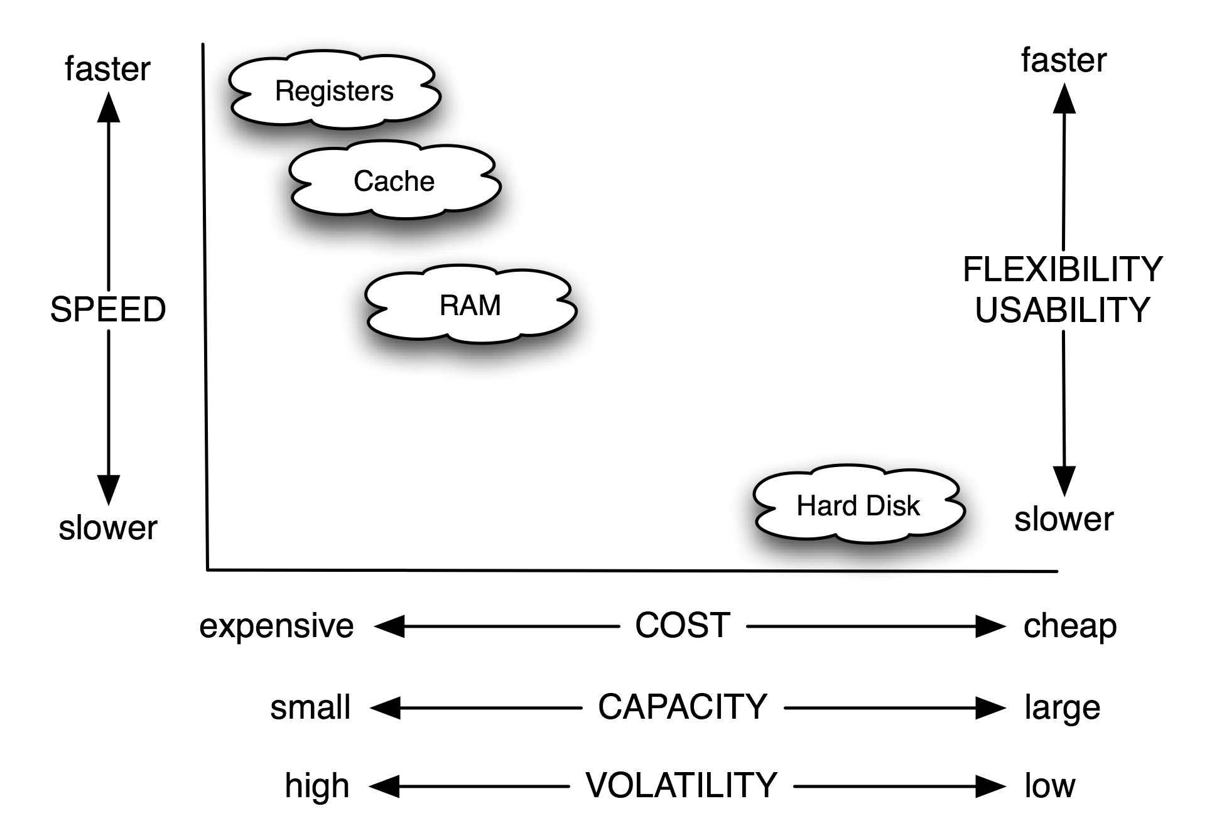

SRAM, DRAM, SDRAM, DDR SDRAM

There are many kinds of RAM and new ones are invented all the time. One of aims is to make RAM access as fast as possible in order to keep up with the increasing speed of CPUs.
SRAM (Static RAM) is the fastest form of RAM but also the most expensive. Due to its cost it is not used as main memory but rather for cache memory. Each bit requires a 6-transistor circuit.
DRAM (Dynamic RAM) is not as fast as SRAM but is cheaper and is used for main memory. Each bit uses a single capacitor and single transistor circuit. Since capacitors lose their charge, DRAM needs to be refreshed every few milliseconds. The memory system does this transparently. There are many implementations of DRAM, two well-known ones are SDRAM and DDR SDRAM.
SDRAM (Synchronous DRAM) is a form of DRAM that is synchronised with the clock of the CPU’s system bus, sometimes called the front-side bus (FSB). As an example, if the system bus operates at 167Mhz over an 8-byte (64-bit) data bus , then an SDRAM module could transfer 167 x 8 ~ 1.3GB/sec.
DDR SDRAM (Double-Data Rate DRAM) is an optimisation of SDRAM that allows data to be transferred on both the rising edge and falling edge of a clock signal. Effectively doubling the amount of data that can be transferred in a period of time. For example a PC-3200 DDR-SDRAM module operating at 200Mhz can transfer 200 x 8 x 2 ~ 3.2GB/sec over an 8-byte (64-bit) data bus.
ROM, PROM, EPROM, EEPROM, Flash

In addition to RAM, they are also a range of other semi-conductor memories that retain their contents when the power supply is switched off.
ROM (Read Only Memory) is a form of semi-conductor that can be written to once, typically in bulk at a factory. ROM was used to store the “boot” or start-up program (so called firmware) that a computer executes when powered on, although it has now fallen out-of-favour to more flexible memories that support occasional writes. ROM is still used in systems with fixed functionalities, e.g. controllers in cars, household appliances etc.
PROM (Programmable ROM) is like ROM but allows end-users to write their own programs and data. It requires a special PROM writing equipment. Note: users can only write-once to PROM.
EPROM (Erasable PROM). With EPROM we can erase (using strong ultra-violet light) the contents of the chip and rewrite it with new contents, typically several thousand times. It is commonly used to store the “boot” program of a computer, known as the firmware. PCs call this firmware, the BIOS (Basic I/O System). Other systems use Open Firmware. Intel-based Macs use EFI (Extensible Firmware Interface).
EEPROM (Electrically Erasable PROM). As the name implies the contents of EEPROMs are erased electrically. EEPROMSs are also limited to the number of erase-writes that can be performed (e.g, 100,000) but support updates (erase-writes) to individual bytes whereas EPROM updates the whole memory and only supports around 10,000 erase-write cycles.
FLASH memory is a cheaper form of EEPROM where updates (erase-writes) can only be performed on blocks of memory, not on individual bytes. Flash memories are found in USB sticks, flash cards and typically range in size from 32M to 2GB. The number of erase/write cycles to a block is typically several hundred thousand before the block can no longer be written.

Main Memory Organisation

Main memory can be considered to be organised as a matrix of bits. Each row represents a memory location, typically this is equal to the word size of the architecture, although it can be a word multiple (e.g. 2xWordsize) or a partial word (e.g. half the wordsize). For simplicity we will assume that data within main memory can only be read or written a single row (memory location) at a time. For a 96-bit memory we could organise the memory as 12x8 bits, or 8x12 bits or, 6x16 bits, or even as 96x1 bits or 1x96 bits. Each row also has a natural number called its address which is used for selecting the row:
Address |  | <–––––––– 8 bit –––––––>
 | 0
 | 1
 | 2
 | 3
 | 4
 | 5
 | 6
 | 7
 | 8
 | 9
 | 10
 | 11

Address |  | <––––––––––––– 12 bit –––––––––––––>
 | 0
 | 1
 | 2
 | 3
 | 4
 | 5
 | 6
 | 7

Address |  | <––––––––––––––––––– 16 bit –––––––––––––––––––>
 | 0
 | 1
 | 2
 | 3
 | 4
 | 5

Byte Addressing

Main-memories generally store and recall rows, which are multi-byte in length (e.g. 16-bit word = 2 bytes, 32-bit word = 4 bytes). Many architectures, however, make main memory byte-addressable rather than word addressable. In such architectures the CPU and/or the main memory hardware is capable of reading/writing any individual byte. Here is an example of a main memory with 16-bit memory locations. Note how the memory locations (rows) have even addresses.
Word Address |  | 16 bit = 2 bytes
 | 0
 | 2
 | 4
 | 6
 | 8
 | 10
 | 12
 | 14
 | 16
 | 18
 | 20

Byte Ordering

The ordering of bytes within a multi-byte data item defines the endian-ness of the architecture.
In BIG-ENDIAN systems the most significant byte of a multi-byte data item always has the lowest address, while the least significant byte has the highest address.
In LITTLE-ENDIAN systems, the least significant byte of a multi-byte data item always has the lowest address, while the most significant byte has the highest address.
In the following example, table cells represent bytes, and the cell numbers indicate the address of that byte in main memory. Note: by convention we draw the bytes within a memory word left-to-right for big-endian systems, and right-to-left for little-endian systems.

Word Address | Big-Endian |  |  |  | Word  Address | Little-Endian
0 | 0 | 1 | 2 | 3 | 0 | 3 | 2 | 1 | 0
4 | 4 | 5 | 6 | 7 | 4 | 7 | 6 | 5 | 4
8 | 8 | 9 | 10 | 11 | 8 | 11 | 10 | 9 | 8
12 | 12 | 13 | 14 | 15 | 12 | 15 | 14 | 13 | 12
MSB –––––––––-> LSB MSB –––––––––––> LSB

Note: an N-character ASCII string value is not treated as one large multi-byte value, but rather as N byte values, i.e. the first character of the string always has the lowest address, the last character has the highest address. This is true for both big-endian and little-endian. An N-character Unicode string would be treated as N two-byte value and each two-byte value would require suitable byte-ordering.
Example: Show the contents of memory at word address 24 if that word holds the number given by 122E 5F01H in both the big-endian and the little-endian schemes?
Big Endian Little Endian
 | MSB | –––––––––> |  | LSB |  | MSB | –––––––––> |  | LSB
 | 24 | 25 | 26 | 27 |  | 27 | 26 | 25 | 24
Word 24 | 12 | 2E | 5F | 01 | Word 24 | 12 | 2E | 5F | 01

Example: Show the contents of main memory from word address 24 if those words hold the text JIM SMITH.
Big Endian Little Endian
 | +0 | +1 | +2 | +3 |  | +3 | +2 | +1 | +0
Word 24 | J | I | M |  | Word 24 |  | M | I | J
Word 28 | S | M | I | T | Word 28 | T | I | M | S
Word 32 | H | ? | ? | ? | Word 32 | ? | ? | ? | H

The bytes labelled with ? are unknown. They could hold important data, or they could be don’t care bytes – the interpretation is left up to the programmer.
Unfortunately computer systems, in use today are split between those that are big-endian, and those that are little-endian. This leads to problems when a big-endian computer wants to transfer data to a little-endian computer. Some architectures, for example the PowerPC and ARM, allow the endian-ness of the architecture to be changed programmatically.
Word Alignment

Although main-memories are generally organised as byte-addressed rows of words and accessed a row at a time, some architectures, allow the CPU to access any word-sized bit-group regardless of its byte address. We say that accesses that begin on a memory word boundary are aligned accesses while accesses that do not begin on word boundaries are unaligned accesses.
Address | Memory (16-bit) word
0 | MSB | LSB | Word starting at Address 0 is Aligned
2
4 |  | MSB | Word starting at Address 5 is Unaligned
6 | LSB
Reading an unaligned word from RAM requires (i) reading of adjacent words, (ii) selecting the required bytes from each word and (iii) concatenating those bytes together => SLOW. Writing an unaligned word is more complex and slower. For this reason some architectures prohibit unaligned word accesses. e.g. on the 68000 architecture, words must not be accessed starting from an odd-address (e.g. 1, 3, 5, 7 etc), on the SPARC architecture, 64-bit data items must have a byte address that is a multiple of 8.
Memory Modules, Memory Chips

So far, we have looked at the logical organisation of main memory. Physically RAM comes on small memory modules (little green printed circuit-boards about the size of a finger). A typical memory module holds 512MB to 2GB. The computer’s motherboard will have slots to hold 2, 4 maybe 8 memory modules. Each memory module is itself comprised of several memory chips. For example here are 3 ways of forming a 256x8 bit memory module.
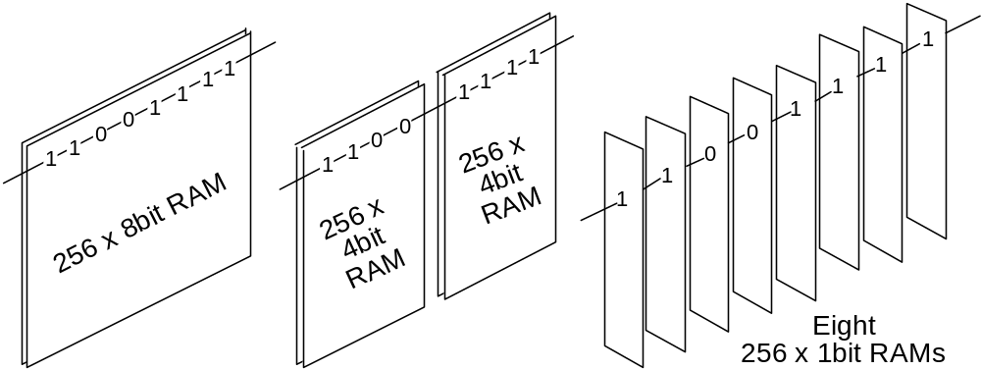

In the first case, main memory is built with a single memory chip. In the second, we use two memory chips, one gives us the most significant 4 bits, the other, the least significant 4 bits. In the third we use 8 memory chips, each chip gives us 1 bit - to read an 8 bit memory word, we would have to access all 8 memory chips simultaneously and concatenate the bits.
On PCs, memory modules are known as DIMMs (dual inline memory modules) and support 64-bit transfers. The previously generation of modules were called SIMMs (single inline memory modules) and supported 32-bit data transfers.
Example: Given Main Memory = 1M x 16 bit (word addressable),
RAM chips = 256K x 4 bit
 | Module 0 |  |  |  |  |  | Module 1 |  |  |  |  |  |  | Module 2 |  |  |  |  |  |  | Module 3
∧  ⏐  218  ⏐  ∨ | C  H  I  P  0 | C  H  I  P  1 | C  H  I  P  2 | C  H  I  P  3 |  |  |  | C  H  I  P  4 | C  H  I  P  5 | C  H  I  P  6 | C  H  I  P  7 |  |  |  | C  H  I  P  8 | C  H  I  P  9 | C  H  I  P  10 | C  H  I  P  11 |  | C  H  I  P  12 |  | C  H  I  P  13 | C  H  I  P  14 | C  H  I  P  15
 | 4x4 bits |  |  |  |  |  | 4x4 bits |  |  |  |  |  |  | 4x4 bits |  |  |  |  |  |  | 4x4 bits

RAM chips per memory module = | Width of Memory Word | = 16/4 = 4
 | Width of RAM Chip

18 bits are required to address a RAM chip (since 256K = 218 = Length of RAM Chip )
A 1Mx16 bit word-addressed memory requires 20 address bits (since 1M =220 )
Therefore 2 bits (=20–18) are needed to select a module.
The total number of RAM Chips = (1M x 16) / (256K x 4) = 16.
Total number of Modules = Total number of RAM chips / RamChipsPerModule = 16/4 = 4
Interleaved Memory

When memory consists of several memory modules, some address bits will select the module, and the remaining bits will select a row within the selected module.
When the module selection bits are the least significant bits of the memory address we call the resulting memory a low-order interleaved memory.
When the module selection bits are the most significant bits of the memory address we call the resulting memory a high-order interleaved memory.
Interleaved memory can yield performance advantages if more than one memory module can be read/written at a time:-
(I) for low-order interleave if we can read the same row in each module. This is good for a single multi-word access of sequential data such as program instructions, or elements in a vector,
(ii) for high-order interleave, if different modules can be independently accessed by different units. This is good if the CPU can access rows in one module, while at the same time, the hard disk (or a second CPU) can access different rows in another module.
Example: Given that Main Memory = 1Mx8bits, RAM chips = 256K x 4bit. For this memory we would require 4x2=8 RAM chips. Each chip would require 18 address bits (ie. 218 = 256K) and the full 1Mx16 bit memory would requires 20 address bits (ie. 220 = 1M )

CPU Organisation & Operation

The Fetch-Execute Cycle

The operation of the CPU is usually described in terms of the Fetch-Execute cycle.
Fetch-Execute Cycle | The cycle raises many interesting questions, e.g.
Fetch the Instruction | What is an Instruction? Where is the Instruction? Why does it need to be fetched? Isn't it okay where it is? How does the computer keep track of instructions? Where does it put the instruction it has just fetched?
Increment the Program Counter | What is the Program Counter? What does the Program Counter count? Increment by how much? Where does the Program Counter point to after it is incremented?
Decode the Instruction | Why does the instruction need to be decoded? How does it get decoded?
Fetch the Operands | What are operands? What does it mean to fetch? Is this fetching distinct from the fetching in Step 1 above? Where are the operands? How many are there? Where do we put the operands after we fetch them?
Perform the Operation | Is this the main step? Couldn't the computer simply have done this part? What part of the CPU performs this operation?
Store the results | What results? Where from? Where to?
Repeat forever | Repeat what? Repeat from where? Is it really an infinite loop? Why? How do these steps execute any instructions at all?

In order to appreciate the operation of a computer we need to answer such questions and to consider in more detail the organisation of the CPU.
Representing Programs

Each complex task carried out by a computer needs to be broken down into a sequence of simpler tasks and a binary machine instruction is needed for the most primitive tasks. Consider a task that adds two numbers, held in memory locations designated by B and C and stores the result in memory location designated by A.
A = B + C
This assignment can be broken down (compiled) into a sequence of simpler tasks or assembly instructions, e.g:
Assembly Instruction | Effect
LOAD R2, B | Copy the contents of memory location designated by B into Register 2
ADD R2, C | Add the contents of the memory location designated by C to the contents of Register 2 and put the result back into Register 2
STORE R2, A | Copy the contents of Register 2 into the memory location designated by A.

Each of these assembly instructions needs to be encoded into binary for execution by the Central Processing Unit (CPU). Let’s try this encoding for a simple architecture called TOY1.
TOY1 Architecture

TOY1 is a fictitious architecture with the following characteristics:
1024 x 16-bit words of RAM maximum. RAM is word-addressable.
4 general purpose registers R0, R1, R2 and R3. Each general purpose register is 16-bits (the same size as a memory location).
16 different instructions that the CPU can decode and execute, e.g. LOAD, STORE, ADD, SUB and so on. These different instructions constitute the Instruction Set of the Architecture.
The representation for integers will be two’s complement.
For this architecture, the architect (us) needs to define a coding scheme for instructions. This is termed the Instruction Format. Lets look at an example before we consider how we arrived at it. Here’s our instruction format for TOY1:
TOY1 Instruction Format

TOY1 instructions are 16-bits (so they will fit into a main-memory word). Each instruction is divided into a number of instruction fields that encode a different piece of information for the CPU.
Field Name  Field Width | OPCODE  4-bits |  |  |  | REG  2-bits |  | ADDRESS  10-bits

The OPCODE field identifies the CPU operation required. Since TOY1 only supports 16 instructions, these can be encoded as a 4-bit natural number. For TOY1, opcodes 1 to 4 will be:
0001 = LOAD 0010 = STORE 0011 = ADD 0100 = SUB
The REG field defines a General CPU Register. Arithmetic operations will use 1 register operand and 1 main memory operand, results will be written back to the register. Since TOY1 has 4 registers; these can be encoded as a 2-bit natural number:
00 = Register 0 01 = Register 1 10 = Register 2 11 = Register 3
The ADDRESS field defines the address of a word in RAM. Since TOY1 can have upto 1024 memory locations; a memory address can be encoded as a 10-bit natural number.
If we define addresses 200H, 201H and 202H for A, B and C, we can encode the example above as:
Assembly Instruction | Machine Instruction
LOAD R2, [201H] | 0001 10 10 0000 0001
ADD R2, [202H] | 0011 10 10 0000 0010
STORE R2, [200H] | 0010 10 10 0000 0000
Memory Placement of Program and Data

In order to execute a TOY1 program, its instructions and data needs to placed within main memory. We’ll place our 3-instruction program in memory starting at address 080H and we’ll place the variables A, B and C at memory words 200H, 201H, and 202H respectively. Such placement results in the following memory layout prior to program execution. For convenience, memory addresses and memory contents are also given in hex.
Memory Address  in binary & hex | Machine Instruction  OP Reg Address | Assembly Instruction
0000 1000 0000  0 8 0 | 10 0000 0001  1 A 0 1 | LOAD R2, [201H]
0000 1000 0001  0 8 1 | 10 0000 0010  3 A 0 2 | ADD R2, [202H]
0000 1000 0010  0 8 2 | 10 0000 0000  2 A 0 0 | STORE R2, [200H]
Etc | Etc | Etc
0010 0000 0000  2 0 0 | 0000 0000 0000 0000  0 0 0 0 | A = 0
0010 0000 0001  2 0 1 | 0000 0000 0000 1001  0 0 0 9 | B = 9
0010 0000 0010  2 0 2 | 0000 0000 0000 0110  0 0 0 6 | C = 6

Of course, the big question is “How is such a program executed by the TOY1 CPU?”
CPU Organisation

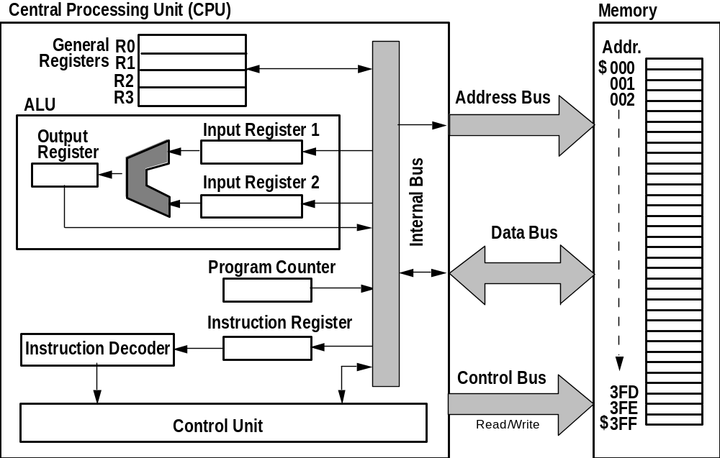

The Program Counter (PC) is a special register that holds the address of the next instruction to be fetched from Memory (for TOY1, the PC is 10-bits wide). The PC is incremented to "point to" the next instruction while an instruction is being fetched from main memory.
The Instruction Register (IR) is a special register that holds each instruction after it is fetched from main memory. For TOY1, the IR is 16-bits since instructions are 16-bit wide.
The Instruction Decoder is a CPU component that decodes and interprets the contents of the Instruction Register, i.e. its splits whole instruction into fields for the Control Unit to interpret. The Instruction decoder is often considered to be a part of the Control Unit.
The Control Unit is the CPU component that co-ordinates all activity within the CPU. It has connections to all parts of the CPU, and includes a sophisticated timing circuit.
The Arithmetic & Logic Unit (ALU) is the CPU component that carries out arithmetic and logical operations e.g. addition, comparison, boolean AND/OR/NOT.
The ALU Input Registers 1 & 2 are special registers that hold the input operands for the ALU.
The ALU Output Register is a special register that holds the result of an ALU operation. On completion of an ALU operation, the result is copied from the ALU Output register to its final destination, e.g. to a CPU register, or main-memory, or to an I/O device.
The General Registers R0, R1, R2, R3 are available for the programmer to use in his/her programs. Typically the programmer tries to maximise the use of these registers in order to speed program execution. For TOY1, the general registers are the same size as memory locations, i.e. 16-bits.
The Buses serve as communication highways for passing information within the CPU (CPU internal bus) and between the CPU and the main memory (the address bus, the data bus, and the control bus). The address bus is used to send addresses from the CPU to the main memory; these addresses indicate the memory location the CPU wishes to read or write. Unlike the address bus, the data bus is bi-directional; for writing, the data bus is used to send a word from the CPU to main-memory; for reading, the data bus is used to send a word from main-memory to the CPU. For TOY1, the Control bus is used to indicate whether the CPU wishes to read from a memory location or write to a memory location. For simplicity we’ve omitted two special registers, the Memory Address Register (MAR) and the Memory Data Register (MDR). These registers lie at the boundary of the CPU and Address bus and Data bus respectively and serve to buffer data to/from the buses.
Buses can normally transfer more than 1-bit at a time. For the TOY1, the address bus is 10-bits (the size of an address), the data bus is 16-bits (size of a memory location), and the control bus is 1-bit (to indicate a memory read operation or a memory write operation).
Interlude: the Von Neumann Machine Model

Most computers conform to the von Neumann’s machine model, named after the Hungarian-American mathematician John von Neumann (1903-57).
In von Neumann’s model, a computer has 3 subsystems (i) a CPU, (ii) a main memory, and (iii) an I/O system. The main memory holds the program as well as data and the computer is allowed to manipulate its own program. In the von-Neumann model, instructions are executed sequentially (one at a time).
In the von-Neumann model a single path exists between the control until and main-memory, this leads to the so-called "von Neumann bottleneck" since memory fetches are the slowest part of an instruction they become the bottleneck in any computation.
Instruction Execution (Fetch-Execute-Cycle Micro-steps)

In order to execute our 3-instruction program, the control unit has to issue and coordinate a series of micro-instructions. These micro-instructions form the fetch-execute cycle. For our example we will assume that the Program Counter register (PC) already holds the address of the first instruction, namely 080H.

LOAD R2, [201H]

0000 1000 0000  0 8 0 | 10 0000 0001  1 A 0 1 | Copy the value in memory word 201H into Register 2

Control Unit Action  FETCH INSTRUCTION | Data flows
PC to Address Bus | 080H | 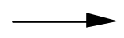 | 080H | Address Bus
0 to Control Bus | 0 |  | 0 | Control Bus
Address Bus to Memory | 080H |  | 080H | Memory
Control Bus to Memory | 0 |  | 0 | Memory
Increment PC | 080 |  | 081H | PC becomes PC+1
Memory [080H] to Data Bus | 1A01H |  | 1A01H | Data Bus
Data Bus to Instruction Register | 1A01H |  | 1A01H | Instruction Register
DECODE INSTRUCTION
IR to Instruction Decoder | 1A01H |  | 1A01H | Instruction Decoder
Instruction Decoder to Control Unit | 1, 2, 201H |  | 1, 2, 201H | Control Unit
EXECUTE INSTRUCTION
Control Unit to Address Bus | 201H |  | 201H | Address Bus
0 to Control Bus | 0 |  | 0 | Control Bus
Address Bus to Memory | 201H |  | 201H | Memory
Control Bus to Memory | 0 |  | 0 | Memory
Memory [201H] to Data bus | 0009H |  | 0009H | Data Bus
Data Bus to Register 2 | 0009H |  | 0009H | Register 2

ADD R2, [202H]

0000 1000 0001  0 8 1 | 10 0000 0002  3 A 0 2 | Add the value in memory word 202H to Register 2

Control Unit Action  FETCH INSTRUCTION | Data flows
PC to Address Bus | 081H |  | 081H | Address Bus
0 to Control Bus | 0 |  | 0 | Control Bus
Address Bus to Memory | 081H |  | 081H | Memory
Control Bus to Memory | 0 |  | 0 | Memory
Increment PC | 081H |  | 082H | PC becomes PC+1
Memory [081H] to Data Bus | 3A02H |  | 3A02H | Data Bus
Data Bus to Instruction Register | 3A02H |  | 3A02H | Instruction Register
DECODE INSTRUCTION
IR to Instruction Decoder | 3A02H |  | 3A02H | Instruction Decoder
Instruction Decoder to Control Unit | 3, 2, 202H |  | 3, 2, 202H | Control Unit
EXECUTE INSTRUCTION
Register 2 to ALU Input Reg 1 | 0009 |  | 0009 | ALU Input Reg 1
Control Unit to Address Bus | 202H |  | 202H | Address Bus
0 to Control Bus | 0 |  | 0 | Control Bus
Address Bus to Memory | 202H |  | 202H | Memory
Control Bus to Memory | 0 |  | 0 | Memory
Memory [202H] to Data bus | 0006H |  | 0006H | Data Bus
Data Bus to ALU Input Reg 2 | 0006H |  | 0006H | ALU Input Reg 2
Control Unit to ALU |  |  | 000FH | Output Register
ALU Output Reg to Register 2 | 000F |  | 000FH | Register 2

STORE R2, [200H]

0000 1000 0001  0 8 2 | 10 0000 0000  2 A 0 0 | Copy the value in Register 2 into memory word 202H

Control Unit Action  FETCH INSTRUCTION | Data flows
PC to Address Bus | 082H |  | 082H | Address Bus
0 to Control Bus | 0 |  | 0 | Control Bus
Address Bus to Memory | 082H |  | 082H | Memory
Control Bus to Memory | 0 |  | 0 | Memory
Increment PC | 082H |  | 083H | PC becomes PC+1
Memory [082] to Data Bus | 2A00H |  | 2A00H | Data Bus
Data Bus to Instruction Register | 2A00H |  | 2A00H | Instruction Register
DECODE INSTRUCTION
IR to Instruction Decoder | 2A00 |  | 2A00 | Instruction Decoder
Instruction Decoder to Control Unit | 2, 2, 200H |  | 2, 2, 200H | Control Unit
EXECUTE INSTRUCTION
Register 2 to Data Bus | 000FH |  | 000FH | Data Bus
Control Unit to Address Bus | 200H |  | 200H | Address Bus
1 to Control Bus | 1 |  | 1 | Control Bus
Data Bus to Memory | 000FH |  | 000FH | Memory
Address Bus to Memory | 200H |  | 200H | Memory
Control Bus to Memory | 1 |  | 1 | Memory

TOY1 Programming

How is computer such as TOY1 programmed? We’ll consider this question with some examples. Let’s first define a basic Instruction Set for the TOY1 architecture:

OP Code | Assembler Format | Action
0000 | STOP | Stop Program Execution
0001 | LOAD Rn, [addr] | Rn = Memory [addr]
0010 | STORE Rn, [addr] | Memory [addr ] = Rn
0011 | ADD Rn, [addr] | Rn = Rn + Memory [addr]
0100 | SUB Rn, [addr] | Rn = Rn – Memory [addr]
0101 | GOTO addr | PC = addr
0110 | IFZER Rn, addr | IF Rn = 0 THEN PC = addr
0111 | IFNEG Rn, addr | IF Rn < 0 THEN PC = addr

Example 1: Multiplication

Given these instructions lets write a TOY1 assembly program, which will perform the following assignment:
A = B * C
where A, B and C denote integers placed at memory words 100H, 101H and 102H respectively. The first point to observe with this example is that a multiply operation is not available in the TOY1 instruction set! Therefore we need to consider if we can use other instructions to carry out the multiplication. The obvious solution is to use repeated addition:
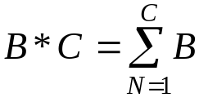
Example: 12 * 3 = 12 + 12 + 12
12 * 1 = 12
12 * 0 = 0
Let’s first write the multiplication algorithm in Pseudo Code

; Given: A, B, C
; Pre: C >= 0 Why do we have this pre-condition?
; Post: A = B * C

sum = 0 ; sum will accumulate the answer
n = C ; n will indicate how many additions remain
loop
exit when n <= 0
sum = sum + B
n = n - 1
end loop
A = sum
Let’s try translating (compiling) this Pseudo Code to TOY1 instructions. Since we have 4 general registers, it is worthwhile allocating frequently used variables to them as this will lead to faster execution. Let’s allocate Register 1 to hold 'sum', and Register 2 to hold 'n'.
sum = 0

The first assignment sum=0 yields our first problem. How do we get zero (or any constant) into a Register?
The only instruction that we can use to set a register is LOAD Rn, addr. Therefore we must reserve a memory word and pre-set it to zero before program execution begins. Lets place zero in memory word 200H. Now to perform sum = 0 we have:
LOAD R1, [200H] ; sum = 0
Let’s place instructions starting at memory word 80H:
Address | Assembler Instruction | Comment
80H | LOAD R1, [200H] | ; sum = 0
200H | 0 | ; holds zero

n = C

The next statement is n = C. This is easy to translate:
81H | LOAD R2, [102H] | ; n = C

exit when n <= 0

What does the loop exit when n <= 0 statement mean in TOY1 terms? Lets consider a simpler example first: loop exit when n = 0. On the TOY1 this statement has a simpler translation, namely:

loop  exit when n = 0  instructions  end loop | Address Instruction  L0 IFZER R2, Ly  L1 instructions  ... ...  Lx GOTO L0  Ly

Note: GOTO alters the Program Counter register thereby causing an unconditional branch in the order of program execution. IFZER alters the Program Counter only if the contents of the specified Register are zero. To handle exit when n <= 0 we need to skip to the end of the loop if R2 is zero or if R2 is negative:

loop  exit when n <= 0  instructions  end loop | Address Instruction  L0 IFZER R2, Ly  L1 IFNEG R2, Ly  L2 instructions  ... ...  Lx GOTO L0  Ly

For our example we now have the following assembly program:

Address | Assembler Instruction | Comment
80H | LOAD R1, [200H] | ; sum = 0
81H | LOAD R2, [102H] | ; n = C
82H | IFZER R2, Ly | ; exit when n<=0
83H | IFNEG R2, Ly | ; we will define Ly when we can
..... | .................. | ...............
Lx | GOTO 82H | ; end loop
Ly | ....
.....
100H | A | ; holds A
101H | B | ; holds B
102H | C | ; holds C
.....
200H | 0 | ; holds 0
sum = sum + B
n = n – 1

Let’s continue with: sum = sum + B. This is easy, namely
84H ADD R1, [101H] ; sum = sum + B
For n = n – 1 we will assume that location 201H is pre-set to the constant 1.
85H SUB R2, [201H] ; n = n–1
201H 1 ; Holds the value 1
end loop
A = sum

Adding STORE R1, 100H for A = sum and a STOP instruction we arrive at the final program:

Addr | Assembler Instruct. | Comment | Machine Instruction
80H | LOAD R1, [200H] | ; sum = 0 | 0001 0110 0000 0000
81H | LOAD R2, [102H] | ; n = C | 0001 1001 0000 0010
82H | IFZER R2, 87H | ; exit when n = 0 | 0110 1000 1000 0111
83H | IFNEG R2, 87H | ; exit when n < 0 | 0111 1000 1000 0111
84H | ADD R1, [101H] | ; sum = sum + B | 0011 0101 0000 0001
85H | SUB R2, [201H] | ; n = n - 1 | 0100 1010 0000 0001
86H | GOTO 82H | ; end loop | 0101 0000 1000 0010
87H | STORE R1, [100H] | ; A = sum | 0010 0101 0000 0000
88H | STOP | ; End of program | 0000 0000 0000 0000
... | ...
100H | A | ; Holds A | initial value of A
101H | B | ; Holds B | initial value of B
102H | C | ; Holds C | initial value of C
... | ...
200H | 0 | ; Holds Zero | 0000 0000 0000 0000
201H | 1 | ; Holds One | 0000 0000 0000 0001

Multiplication (An improvement)

The multiply program will work correctly but can be improved. Consider 3 * 1000 if C is greater than B then it will be faster to compute 1000 * 3. How can we adapt our program to handle this case? Consider and work through the following solution:
sum = 0  if B <= C then  big=C, n=B  else C < B  big=B, n=C  end if  loop exit when n <= 0  sum = sum + big  n = n – 1  end loop  A = sum | Addr Instruction  80H LOAD R1, [200H] ; sum=0  81H LOAD R0, [102H ] ; if C<B  82H SUB R0, [101H] ; then ELSE  83H IFNEG R0, 88H  84H LOAD R0, [102H] ; then  85H STORE R0, [202H ]; big = C  86H LOAD R2, [101H] ; n = B  87H GOTO 8BH  88H LOAD R0, [101H] ; else  89H STORE R0, [202H ]; big=B  8AH LOAD R2, [102H ]; n=C  8BH etc ; loop....  ...  202H ... ; Holds big
Example 2: Vector Sum

Write a sequence of TOY1 instructions (and constants) to sum 100 integers stored consecutively starting at memory word 200H. The sum is to be left in Register 0.
Again, lets first write the Pseudo Code for the problem:
sum = 0
n = 100
addr = 200H
loop
exit when n <= 0
sum = sum + RAM [addr]
addr = addr + 1
n = n - 1
end loop

Looking at this code, we find that the main "difficulty" is how to perform
sum = sum + RAM [addr]
There doesn't appear to be any way of accessing memory words based on a "Variable". We need therefore to extend TOY1 to include an indirect addressing capability.

Indirect Addressing Instructions for TOY1

OP Code | Assembler Format | Action
1001 | LOAD Rn, [Rm] | Rn = Memory [Rm]
1010 | STORE Rn, [Rm] | Memory [Rm] = Rn
1011 | ADD Rn, [Rm] | Rn = Rn + Memory [Rm]
1100 | SUB Rn, [Rm] | Rn = Rn – Memory [Rm]

A second Instruction Format is also needed for these instructions. We will use the following:
OPCODE | REGn | REGm | Unused
4-bits | 2-bits | 2-bits | 8-bits

Example: Given this format the TOY1 instruction ADD R1, [R2] would be coded as
1011 01 10 0000 0000 in binary or B600H in hexadecimal.
Vector Sum Example Contd.

The vector sum example is now straightforward. This program will be placed at 0FH onwards, and the registers allocated as follows: R0 for 'sum', R1 for 'n', R2 for 'addr'
sum = 0  n = 100  addr = 200H  loop  exit when n <= 0  sum = sum + RAM [addr]  addr = addr + 1  n = n - 1  end loop  ; Result in Register R0 | 0 0 ; Holds 0  1 1 ; Holds 1  2 100 ; Holds 100  3 200H ; Holds 200H  ...  0FH LOAD R0, [0] ; sum = 0  10H LOAD R1, [2] ; n = 100  11H LOAD R2, [3] ; addr = 200H  12H IFZER R1, 18H ; exit when n<=0  13H IFNEG R1, 18H  14H ADD R0, [R2] ; sum = sum+...  15H ADD R2, [1] ; addr = addr + 1  16H SUB R1, [1] ; n = n – 1  17H GOTO 12H ; end loop  18H STOP

More ambitious students might also wish to consider Computer Organisation & Design by David. A. Patterson and John. L. Hennessey, Morgan Kaufmann Publishing.
e.g. less than a nanosecond (10-9 sec)
Occasionally called Working Registers
Used for performing calculations, moving and manipulating data etc.
Actually many computers systems also include Cache memory, which is faster than Main memory, but slower than register memory. We will ignore Cache memories in this course.
1K = 210= 1024, 1M = 220, 1G = 230 , ‘B’ will be used for Bytes, and ‘b’ or ‘bit’ for bits, cf. 1MB and 1Mbit
There are many types of RAM technologies.
Random is a Misnomer. Direct Access Memory would have been a better term.
Typically a byte multiple.
e.g. less than 10 nanoseconds (10x10-9 sec)
Some RAM locations (typically those with the lowest & highest addresses) may cause side-effects, e.g. cause data to be transferred to/from external devices
Some authors refer to disk memory as disk storage.
For details about how disks and other storage devices work, check out Tanenbaum or Stallings.
The concept of an address is very important to properly understanding how CPUs work.
To avoid confusion we will use the term memory word for a word-sized memory location.
The interested student might want to read the paper, “On Holy Wars and a Plea for Peace”, D. Cohen, IEEE Computer, Vol 14, Pages 48-54, October 1981.
The Motorola 68000 architecture is big-endian, while the Intel Pentium architecture is little-endian.
Describe a method for doing an unaligned word write operation.
Central Processing Unit.
Sometimes called the Fetch-Decode-Execute Cycle.
Let’s assume they are held in two’s complement form.
A, B and C are actually main memory addresses, i.e. natural binary numbers.
Most architectures actually have different instruction formats for different categories of instruction.
Operation Code
The meaning of CPU operations is defined in the Architecture’s Instruction Set Manual.
The Operating System software is normally responsible for undertaking this task.
By the appropriate number of memory words.
Most control-buses are wider than a single bit, these extras bits are used to provide more sophisticated memory operations and I/O operations.
This type of manipulation is not regarded as a good technique for general assembly programming.
The micro-steps in the Fetch and Decode phases are common for all instructions.
This and the next 4 micro-steps initiate a fetch of the next instruction to be executed, which is to found at memory address 80H. In practice a Memory Address Register (MAR) acts as an intermediate buffer for the Address, similarly a Memory Data Register (MDR) buffers data to/from the data bus.
We will use 0 for a memory READ request, and 1 for a memory WRITE request.
For simplicity, we will assume that the PC is capable of performing the increment internally. If not, the Control Unit would have to transfer the contents of the PC to the ALU, get the ALU to perform the increment and send the results back to the PC. All this while we are waiting for the main-memory to return the word at address 80H.
Since TOY1’s main-memory is word-addressed, and all instructions are 1 word. If main-memory was byte-addressed we would need to add 2.
The Instruction decoder splits the instruction into the individual instruction fields OPCODE, REG and ADDRESS for interpretation by the Control Unit.
The micro-steps for the execute phase actually perform the operation.
Using two’s complement arithmetic.
Note: Only half of the possible sixteen instructions are defined. The remaining 8 will be defined later. The STOP instruction does not make use of the Register or Address fields, while the GOTO instruction does not make use of the Register field.
Try to comment each line of an assembly-language program.
In fact there is a way of writing this program without resorting to indirect memory access instructions. Can you think what the way might be?
Memory [Rm] denotes the contents of the memory word whose address is given by Register m.
Is having more than one instruction format a good idea?
For these instructions 8-bits are unused. A more advanced CPU could allow two address-indirect instructions to be encoded into one word, thus skipping one instruction fetch.

